openEuler
Installation Guide on Hyper-V in Windows 10.

Contents
Hyper-V 2
Installation in Windows 10 2
Hyper-V External switch configuration 3
Create a Virtual Machine in Hyper-V 6
Attach a DVD ISO file to VM to Install OS 10
Change the boot order of VM 11
Modify properties of the VM 12
Disable secure boot 13
Start, stop and connect to the VM 14
openEuler Linux installation 16
Server description 16
Installation procedure 17

Hyper-V

Installation in Windows 10

For this task, you must have administrative right in the computer.
Procedure
- Open control panel
- In programs and features, select Turn Windows Features on or Off
- Select Hyper-V Management Tools and Hyper-V Platform in Hyper-V.
- Reboot the Machine.

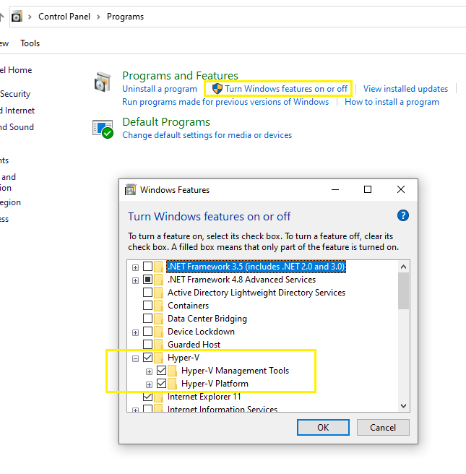

Hyper-V External switch configuration
By default the Hyper-V create a default virtual switch. It automatically gives virtual machines access to the computer´s network using NAT (Network address translations), but the external computer cannot access to the Virtual machine.
An External switch, binds to the physical network adapter of the computer, so that virtual machines can access to external network and the external computer can access to the Virtual machine connected to the external switch.
In this example I will binds the External switch to the Wi-Fi adapter of my computer.
Procedure
- Open Hyper-V manager
- Right click in your computer. Select Virtual Switch Manger.
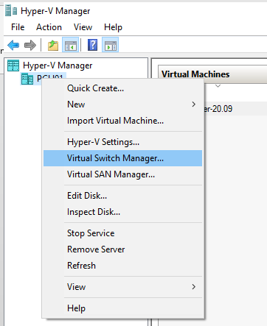

- Select New Virtual network switch External Create Virtual Switch.
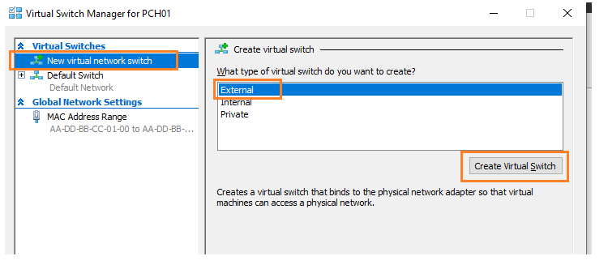

- In the next screen, make this changes.
Name: External Switch.
Connection Type: External Network
Select the interface you will use to connect to external network the machine. I’m using the Wi-Fi adapter.
Note: The Machine must be in the same network segment of the physical computer.
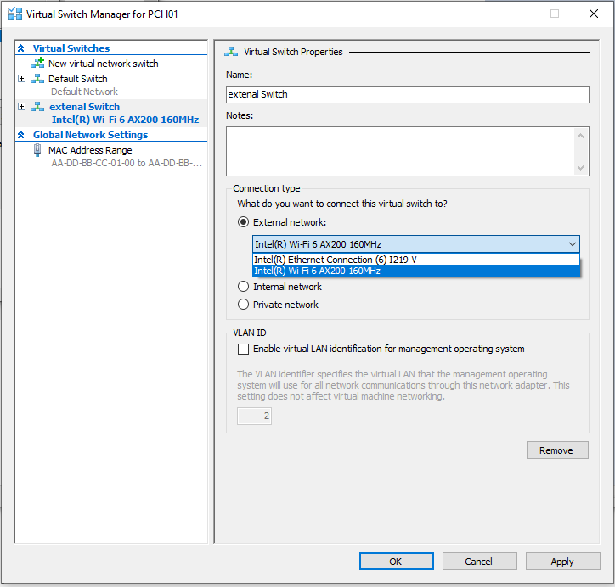
- Click in apply.
Warning. In this steps the computer lose network connectivity for seconds.
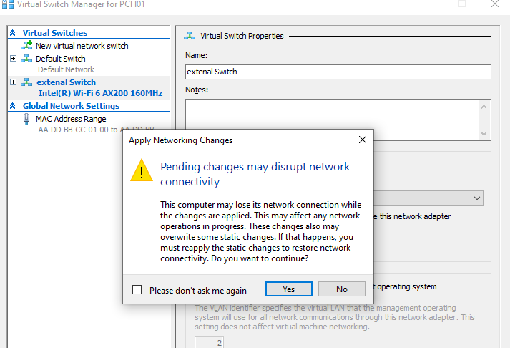

- After finish the change, click in OK.

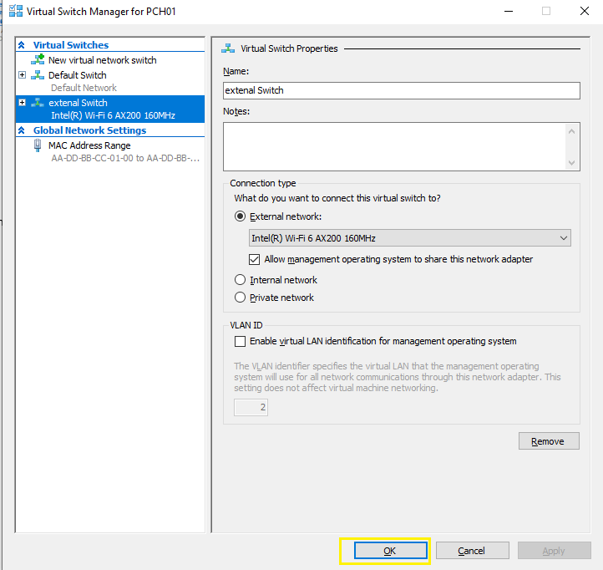

Create a Virtual Machine in Hyper-V

The VM we are creating has access to the external network, so It
- Disk size: 50 GB.
- RAM: 3 GB
- vCPU: 4
- Network: External Access (connect to external system and external system can connect to the VM).

Procedure
- Open Hyper-V manager
- Right click in your computer
- Select new Virtual machine
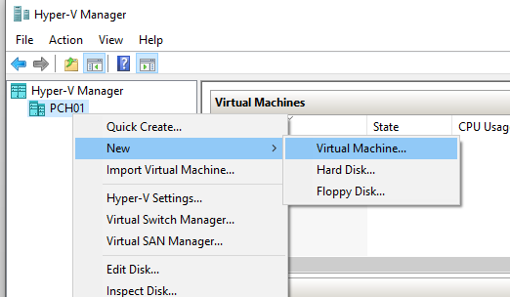

- Select Next
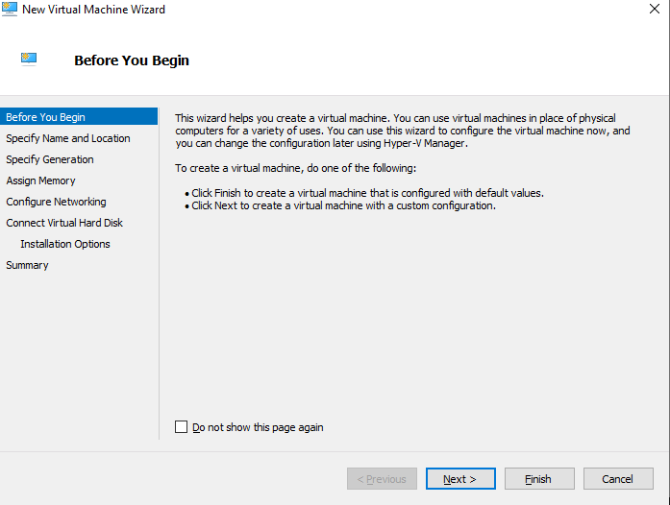

- Input the name and the disk location. The disk will be in the directory C:\VMs\linux\. Then Next.
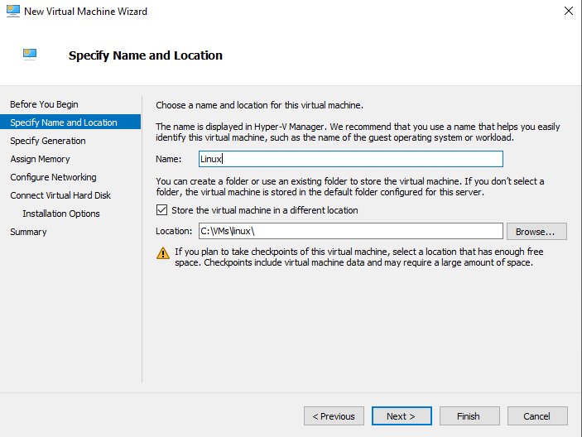
- Select the Generation 2. Then next.

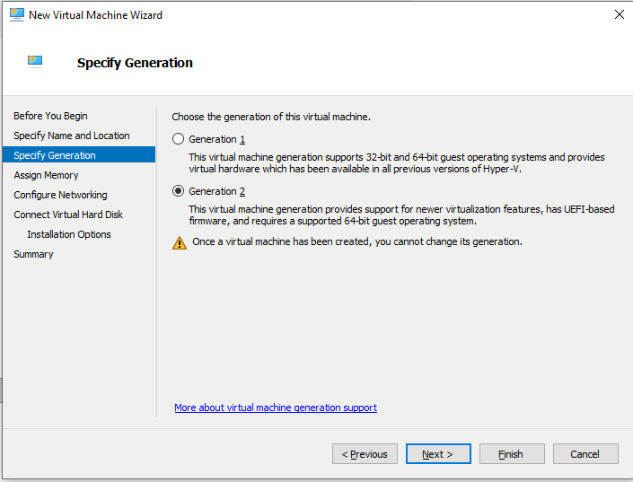
- Specify the ram memory in Mb. Uncheck “Use Dynamic Memory for this virtual machine”.
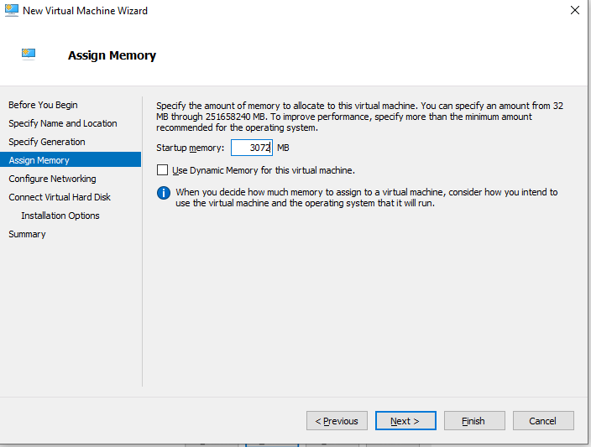

- Configure Networking. Select External Switch in connection. Then Next.
Note: this external switch was created earlier.

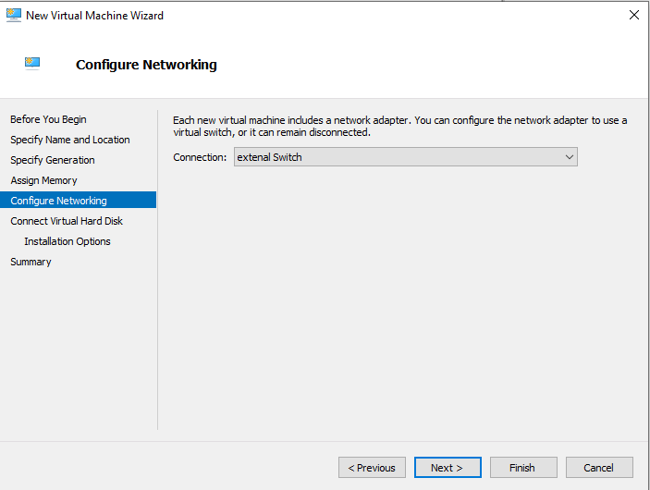

- Input the disk size, in the example is 50 GB. In this section you can use a disk create before.
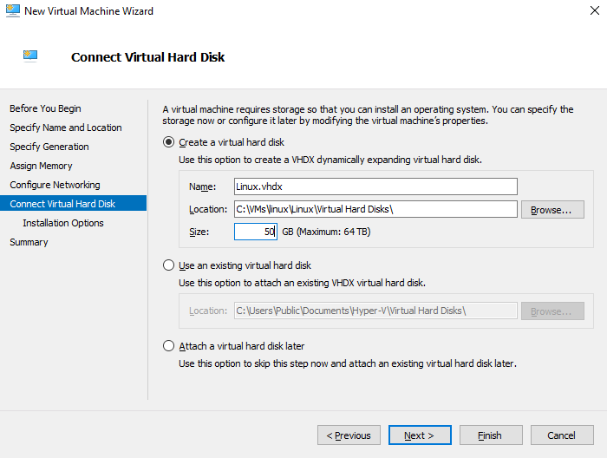

- Next screen is to select how the Operating system will be installed. Select Install Operating system later.
You can also attach ISO file to boot the VM or install it by PXE network.
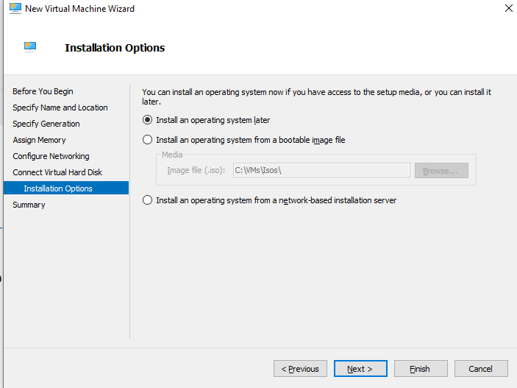

- Click finish in the summary.
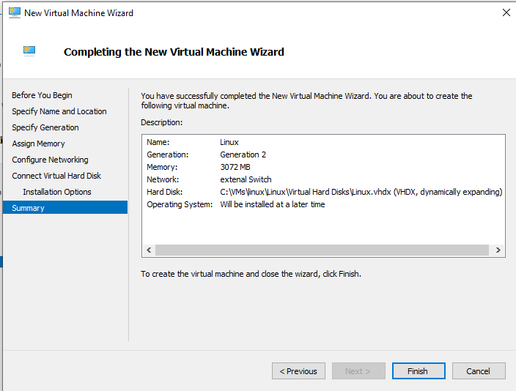

Attach a DVD ISO file to VM to Install OS

To attach an ISO file to install the operating system, follow the procedure.
- Select the VM, then clink in settings.
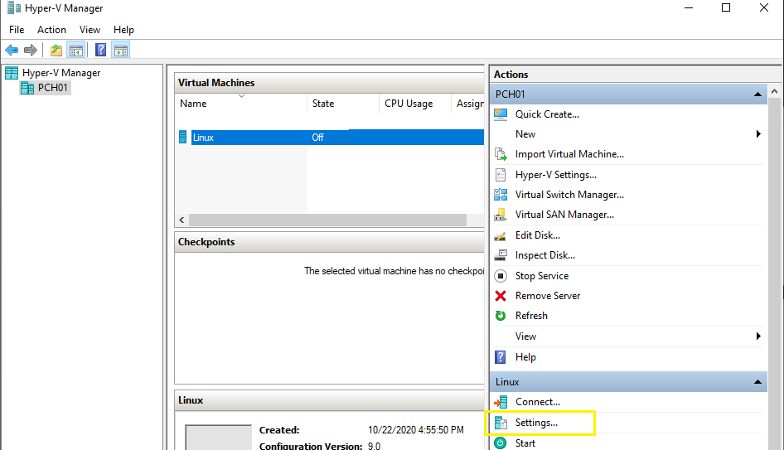

- Select DVD drive in the SCSI Controller add
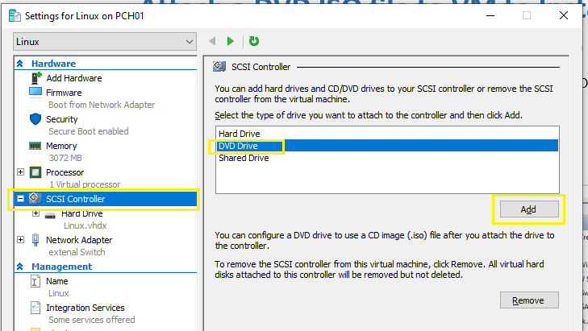

- In Media, select ISO file.
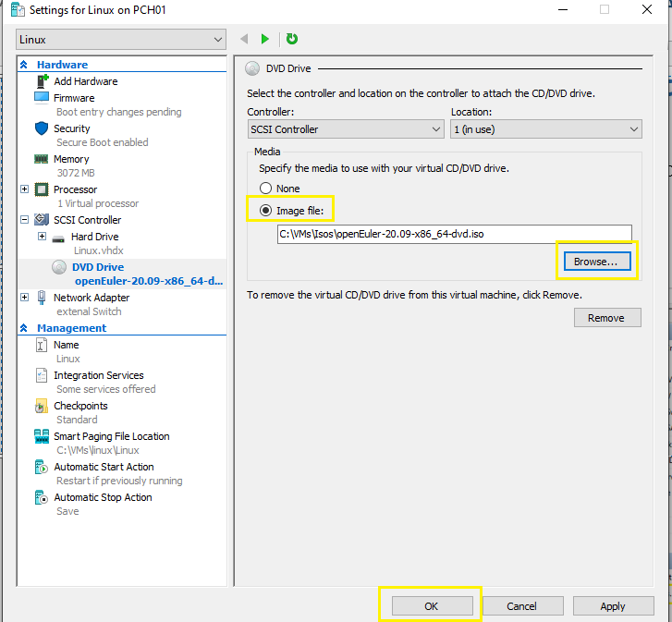

Change the boot order of VM

To change the media to boot the VM, follow this procedure. In this example the first option is DVD drive.
- Select the VM, then clink in settings.
- In firmware, select the boot order. Select it, moving with the buttons move up/down.
Note; After the installation of the OS ends, you should change the order or disconnect the ISO file.
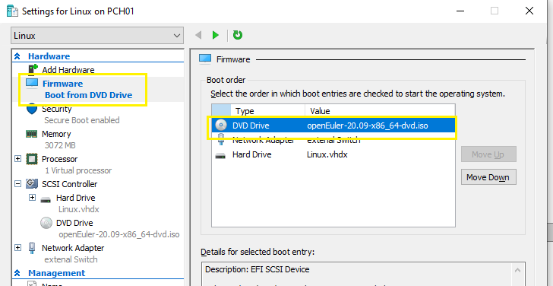

Modify properties of the VM

To change the properties of the vCPU, memory etc., the VM should be power off, then follow the procedure.
- Select the VM, then clink in settings.
- Select the property you need to change, then click in Ok button.
Here I have change the number of vCPU.
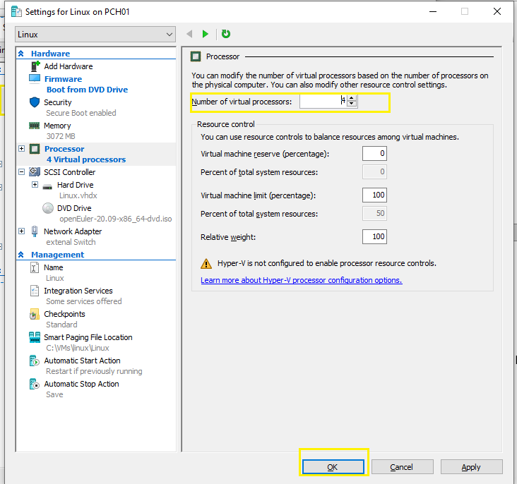

Disable secure boot

Most Linux distributions does not support the secure boot. In order to install and boot Linux in Hyper-V, the secure boot must be disabled.
- Select the VM, then clink in settings.
- In security disable “Enable Secure boot”
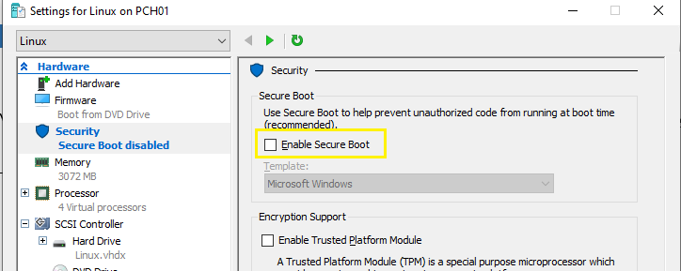

Start, stop and connect to the VM

- To start right click in the VM the select start.
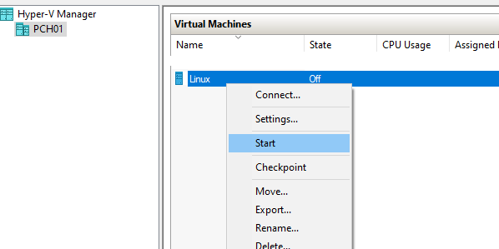
- To open the console, right click in the VM then select Connect …
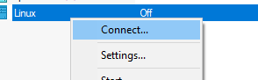
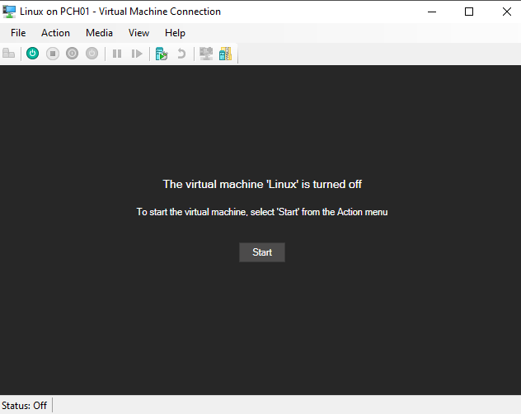

After configure all the previous steps you can start the VM and start the Linux OS installation.
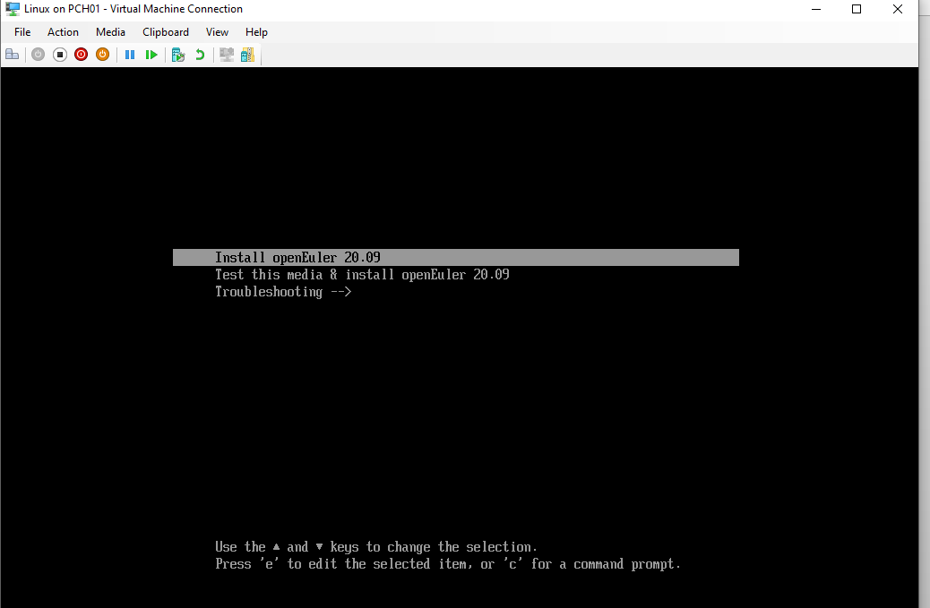

openEuler Linux installation

Server description

For this example, the spects of the server server are listed in next list:

- Hard Disk: 35 GB.
- RAM: 3 Gb
- vCPU: 4
- System Name: openeuler-01
- Username: admin-user
- IP: 10.254.254.20
- Mask: 255.255.255.0
- Gateway: 10.254.254.1
- DNS1: 10.254.254.11
- DNS2: 10.254.254.12
- Ipv6: Disable
- Time Zone: Mexico city

The hard disk is partitioned according to next table.
Note: In production you need to change the layout according to your needs.
Disk partition | Partition Type | Volume Group name | Logical Volume name | Mount Point | File system | Size (GB)
/dev/sda1 | Physical |  |  | /boot/efi | EFI File system | 1
/dev/sda2 | Physical |  |  | /boot | ext4 | 1
/dev/sda2 | Logical volume for LVM | vg-openeuler | lv-root | / | ext4 | 1
 |  |  | lv-swap | swap | ext4 | 1
 |  |  | lv-tmp | /tmp | ext4 | 500 Mb
 |  |  | lv-opt | /opt | ext4 | 10
 |  |  | lv-home | /home | ext4 | 10
 |  |  | lv-var | /var | ext4 | 2
 |  |  | lv-varlog | /var/log | ext4 | 1
 |  |  | lv-usr | /usr | ext4 | 5
 |  |  | lv-dump | /dump | ext4 | 2

Installation procedure

- Boot with the ISO file, then select Install openEuler . You can download the ISO from https://openeuler.org/en/download/

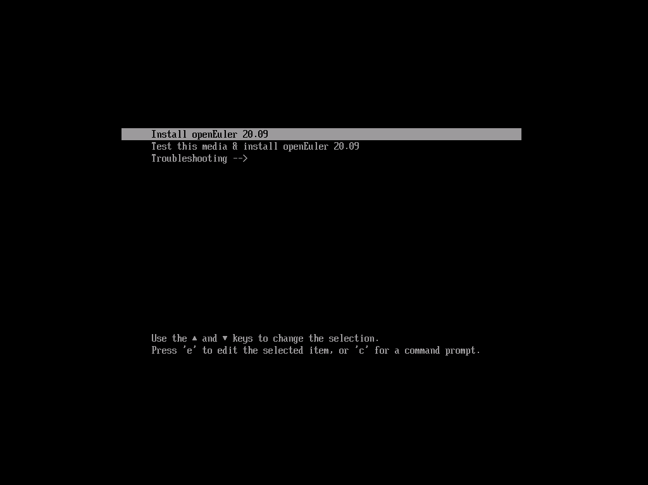

- Select the language English (Or Chinese). Then Next.
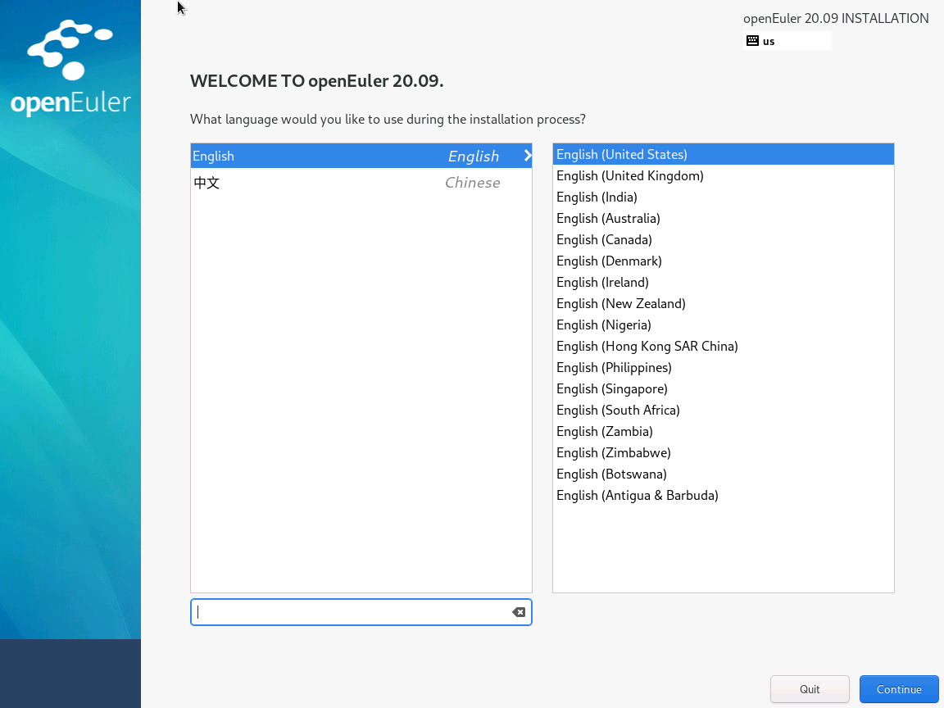

- In the Installation summary, you need to customize the installation settings.

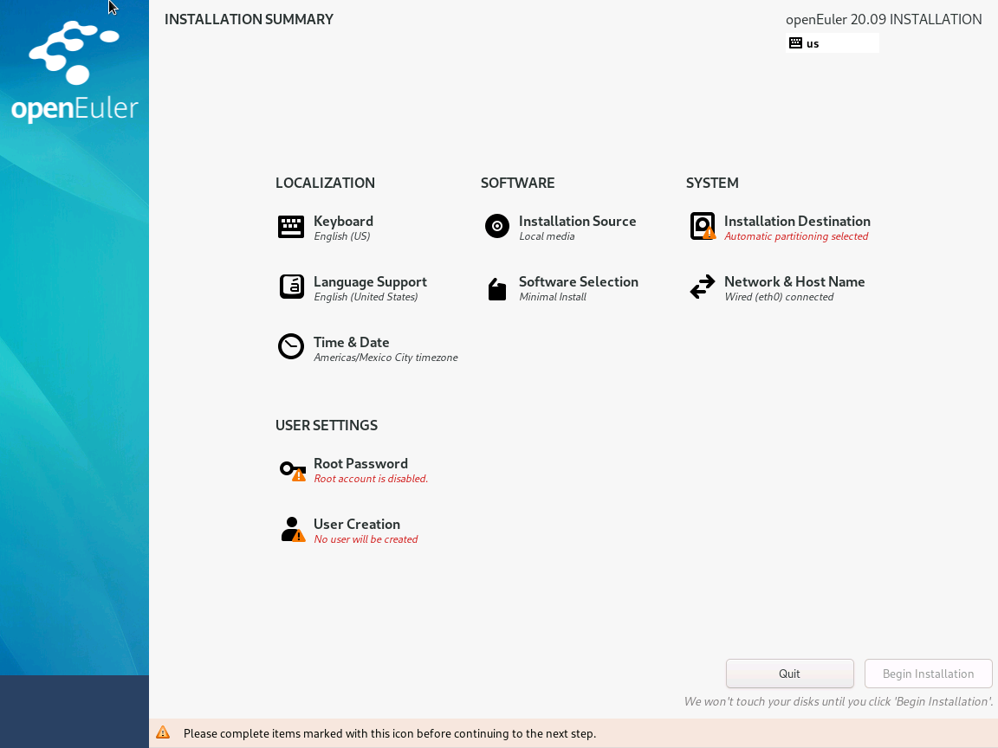

  - In the Installation summary, Select Installation Destination
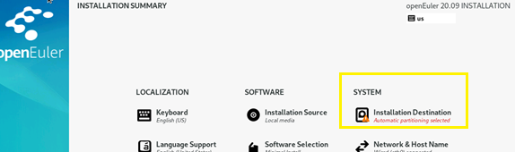

  - Select the disk where the OS will use then select Custom. Finally select done button.

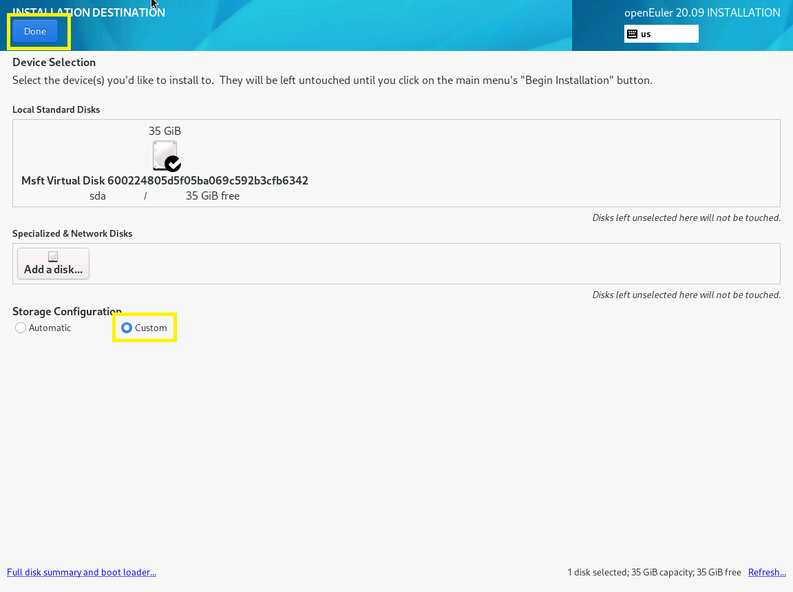

  - In next section you can create the partitions.
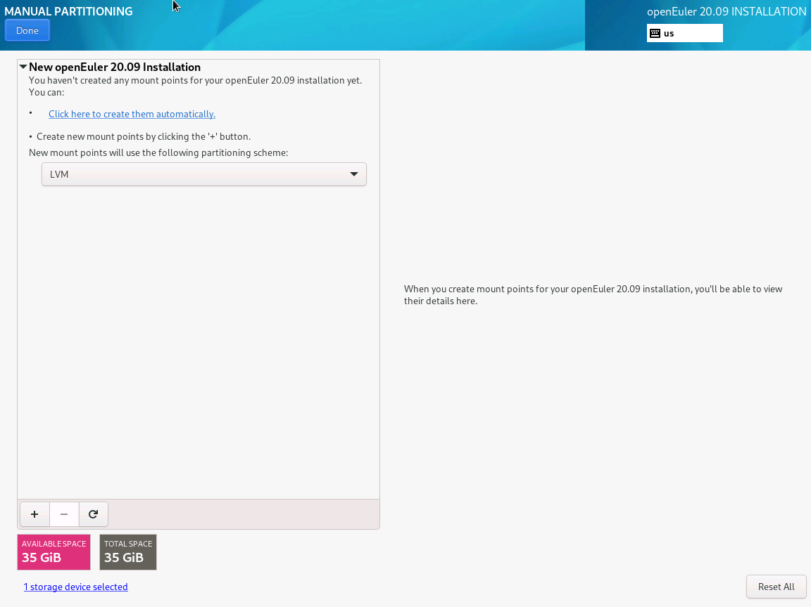

Create EFI filesystem.
Select sign + to add the filesystem:
Create the /boot/efi for system that support UEFI.
Mount Point: /boot/efi
Desired Capacity: 1 GB
Click Add mount Point

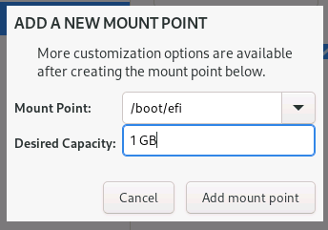
The in the screen of the efi file system, select:
Device Type: Standard Partition
File System: EFI System Partition

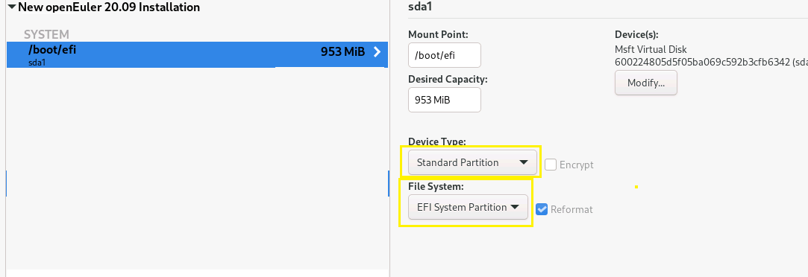

Create boot filesystem.
For /boot file system
Select sign + to add the filesystem:
Input /boot in Mount point and 1 GB as Desired Capacity. Then click in Add mount Point.

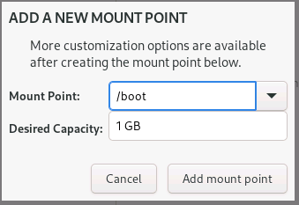

Note: This selection prepare a physical partition in the disk automatically
In the next screen, select:
Device type: Standard Partition
File System: ext4
Label (is not necessary): boot
Click: Update Settings

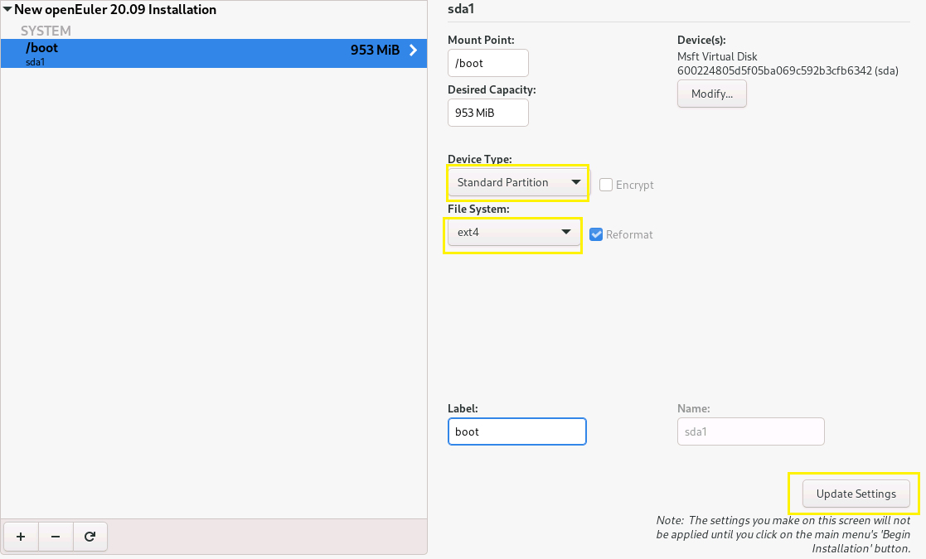
Create root / filesystem.
Click in + button
Mount Point: /
Desired Capacity: 1 GB
Click: Add mount point

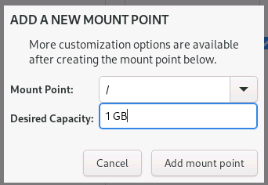

Note: This selection prepare a LVM partition in the disk automatically
In the next windows,
- Device type: LVM
- File system: ext4
- Volume group: vg-openeuler

Change the name of volume group from openeuler to vg-openeauler, click in the button modify, below to “Volume group”.

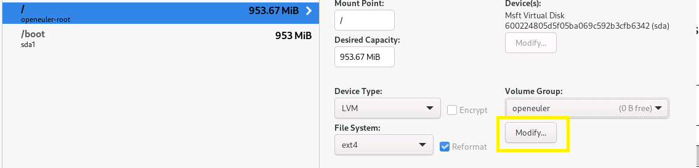

In name change to vg-openeuler, then click in save button.

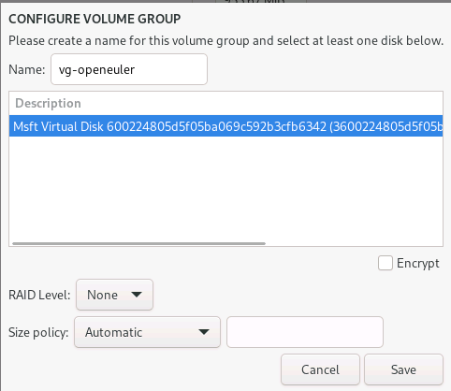

Change the name from root to lv-root in Name, then click in update setting button.
The screen for / portion should looks like this screenshot:

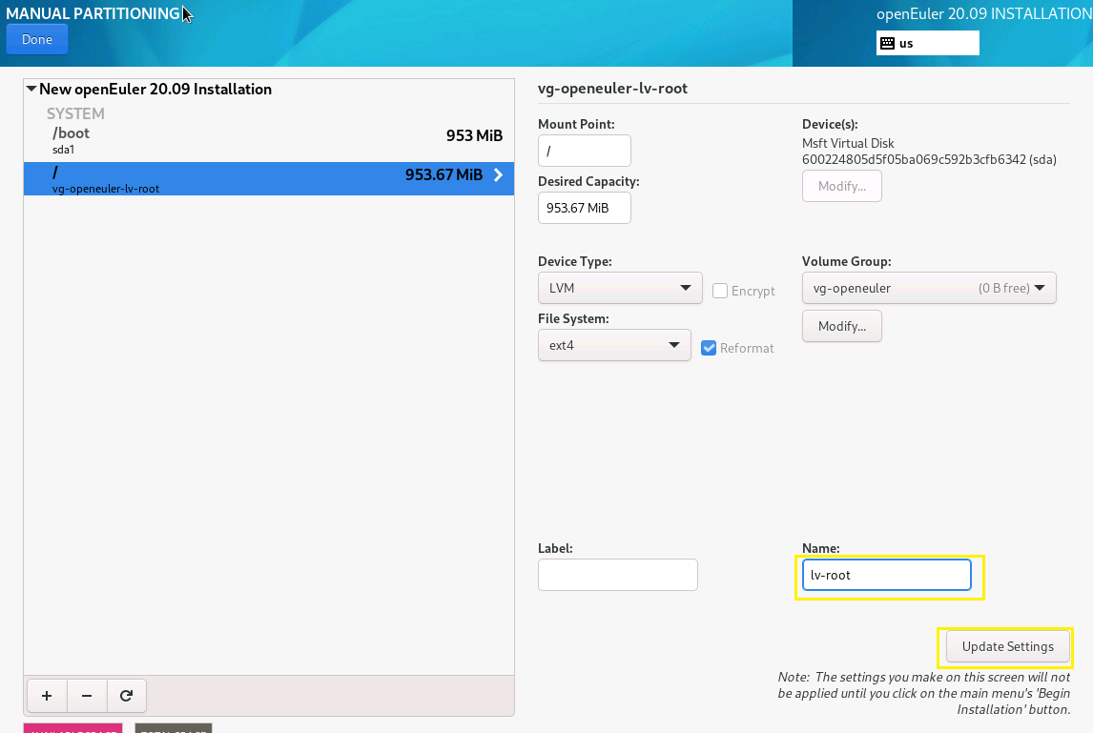

Create swap filesystem.
For swap partition the procedure is:
Click in +
Mount Pont: swap
Desired capacity: 1 GB
Click Add mount point
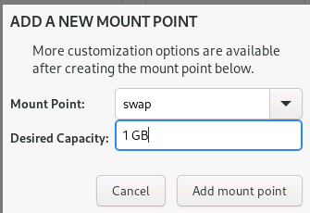

The image bellow shows the setting for swap file system. The File System, should be swap. Remember change the name to lv-swap. Finally click in Update Settings.
Note: is not necessary to change again the name of Volume Group.
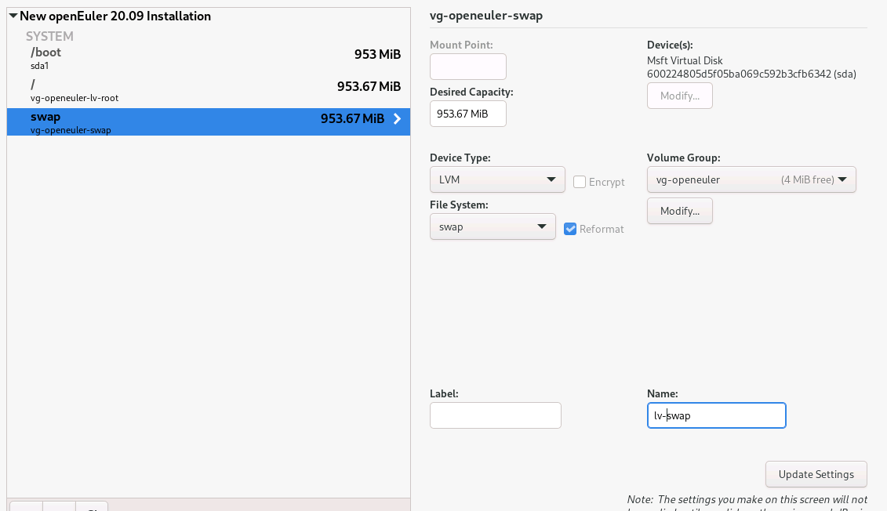

Create the others filesystem.
Continue with the same procedure for all the file system, we have planned before. The Filesystem should be ext4.
After finish create the file system, select done.

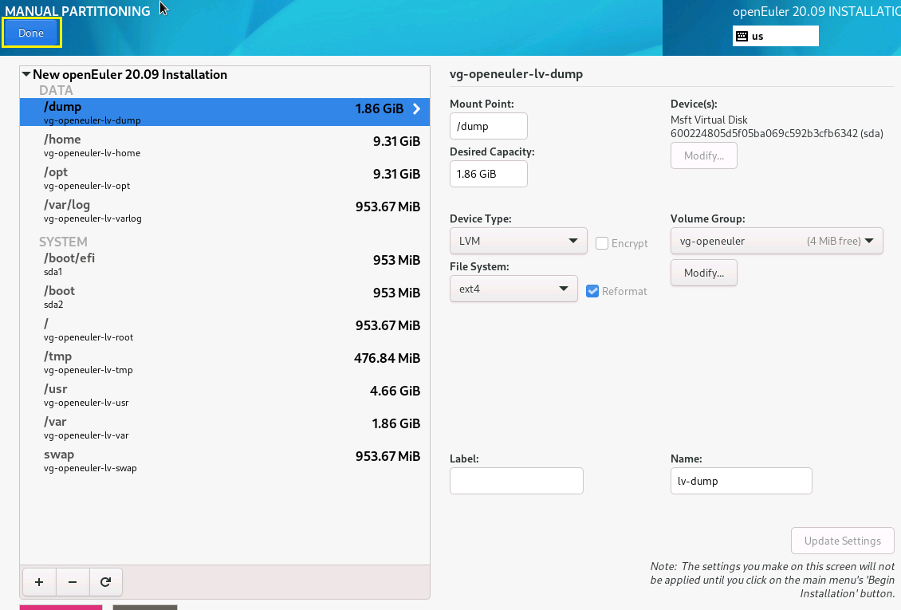

The installer inform about the change in disk, click in Accept Change.
Warning: after begins the installation, the disk id formatted and all the data is destroyed.

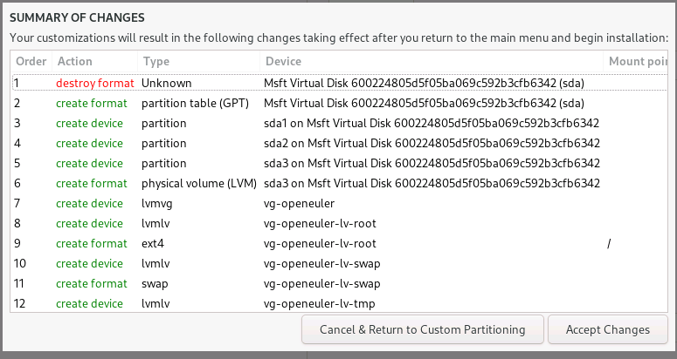
- Software Selection:
Click in software selection
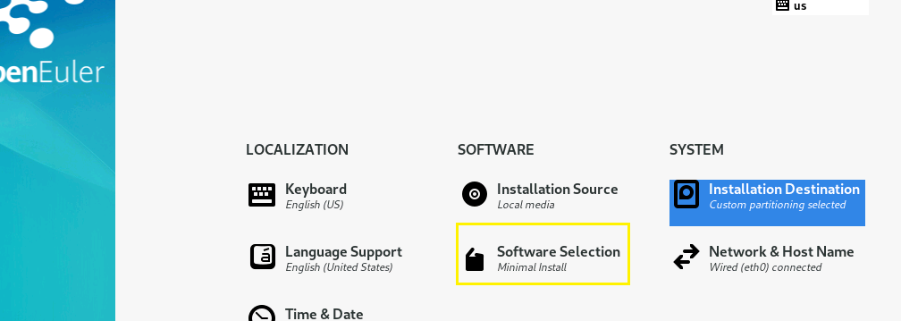

Select Minimal install and then Done button.
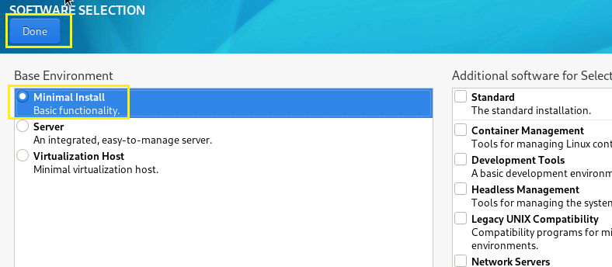

- Network configuration:
Select Network & Host Name
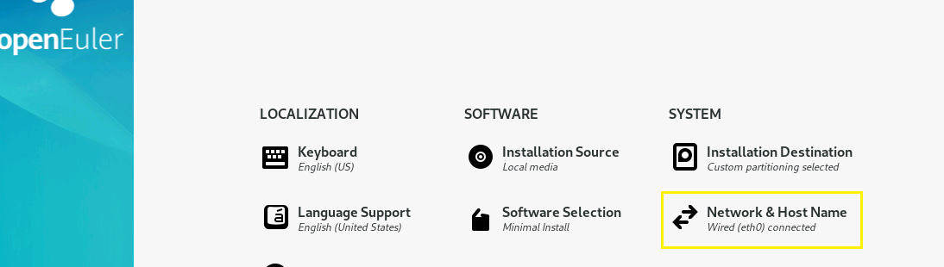
  - Change the host name
Input the name in Host Name then click in apply button.
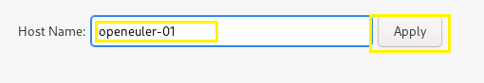

  - Configure the Network
Ipv4:
Enable the switch to On to connect the interface
Click in Configure:

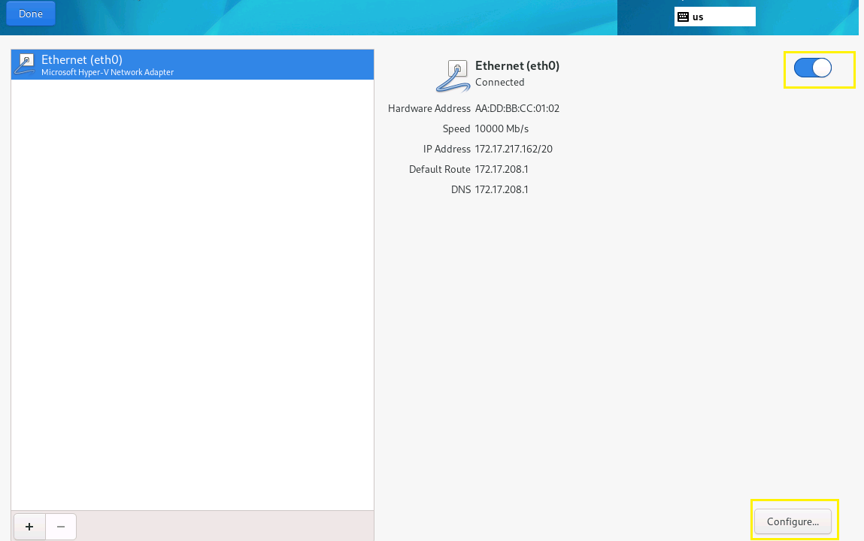

- Select IPv4 Settings
- Method: Manual
- Click Add: Duble click in the input text and insert the IP, mask and gateway.
- Input the DNS separate the IP with a comma.
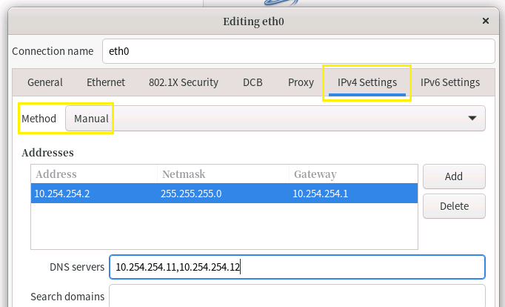

- Select IPv6 setting and select disable.
- Click in save
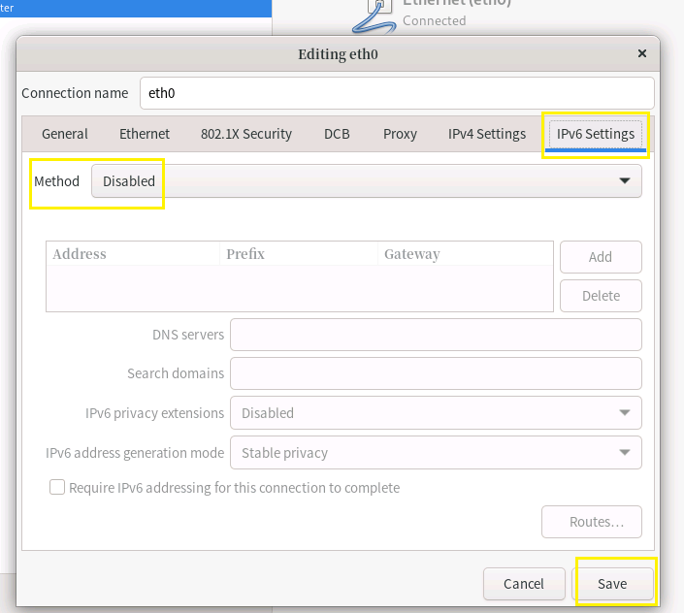

Review the information and then click in Done button.
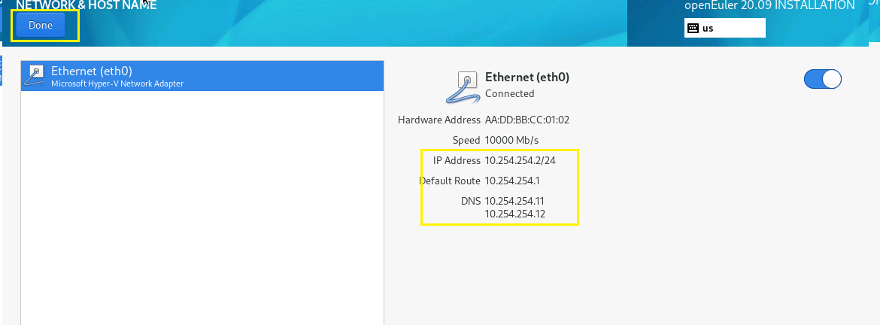

- Time Zone:
Select Time & Date
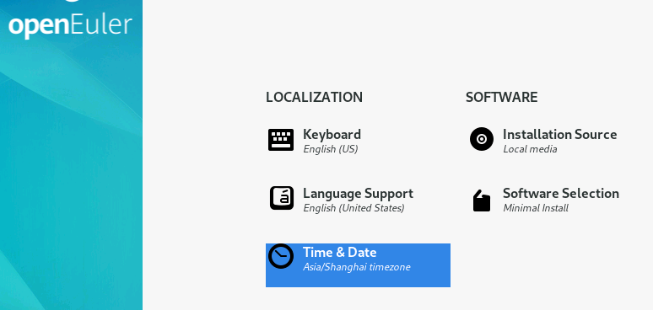

Select the time zone. Select the time zone in map. Then click in Done button.
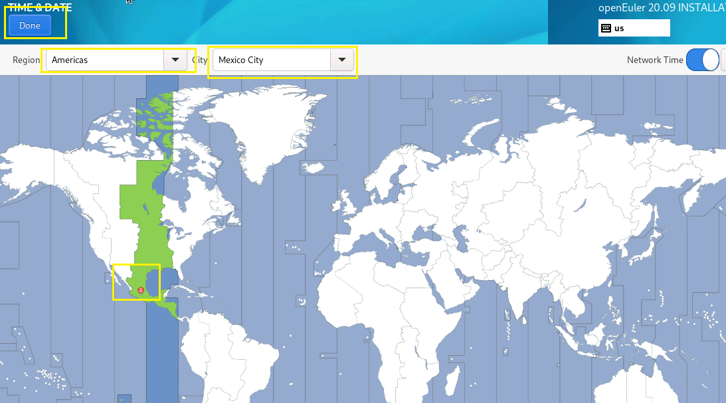

- Root Password:
Select root password
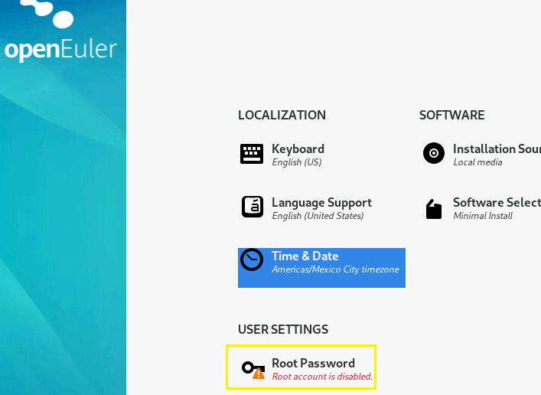

Type the password, then click in Done Button.

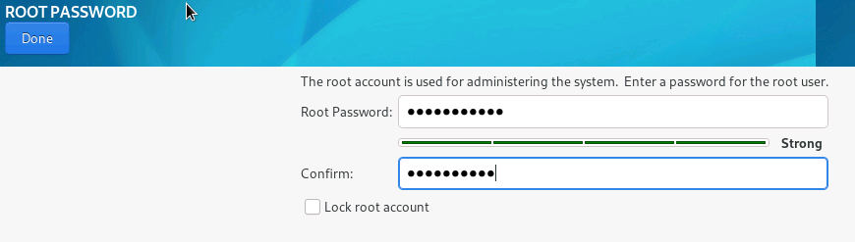

- Create a use:
Select User creation
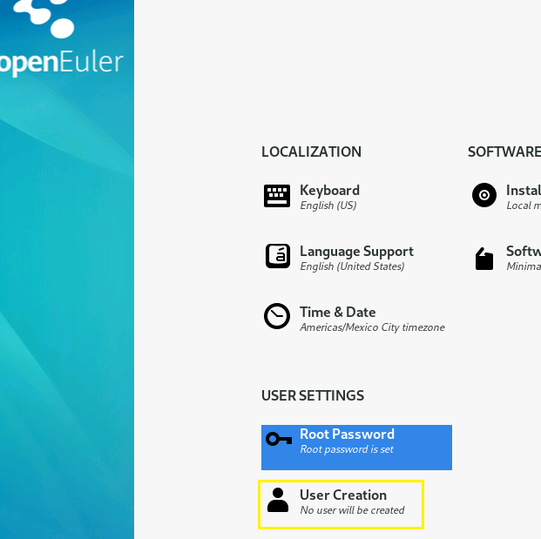

Input the username and password. Then click in Done button.

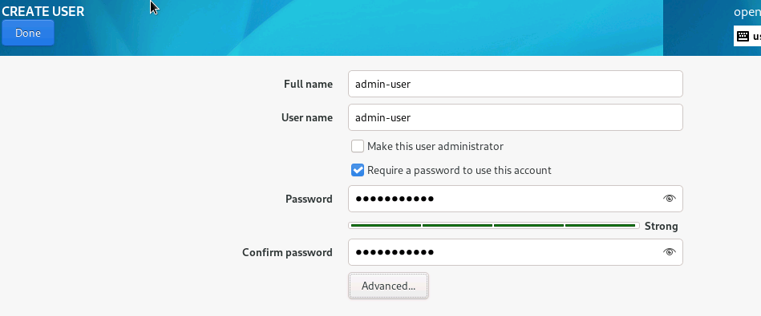

- Start the installation:

In the summary screen, select Begin installation.

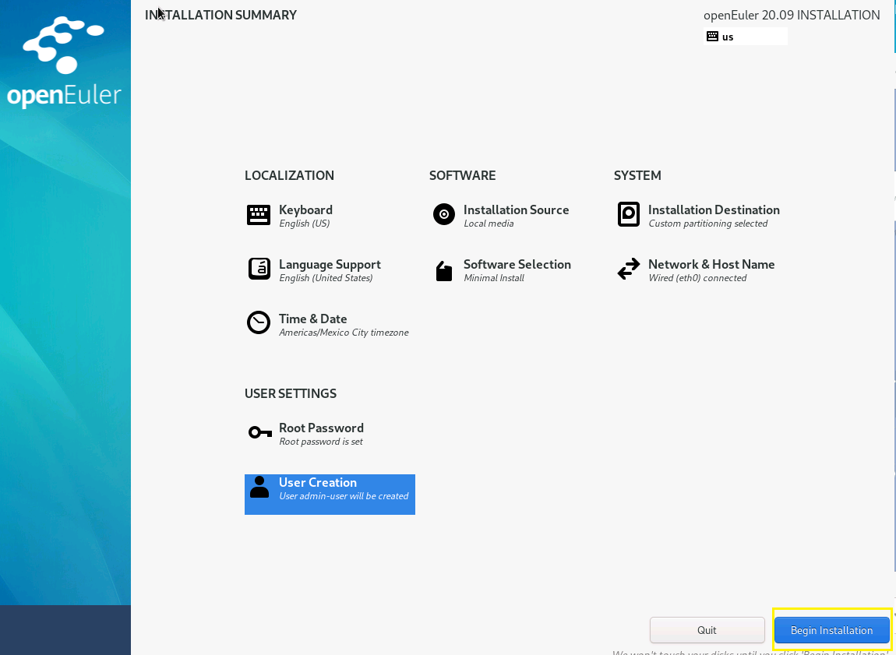

Wait until the installation ends.

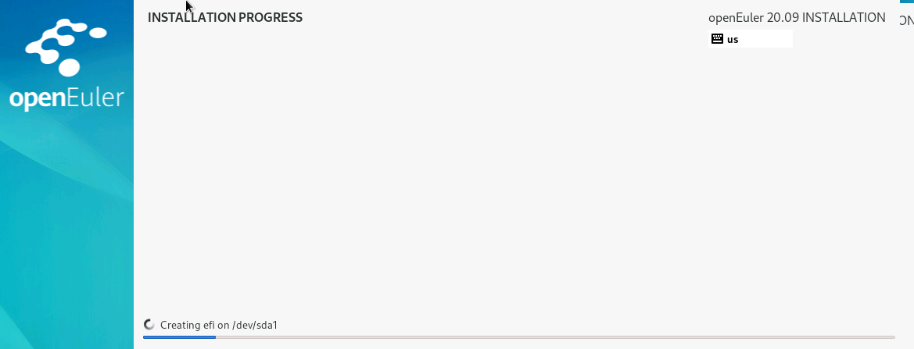

After complete, click in Reboot system
Note: Ensure that the machine boot from disk not by ISO file.

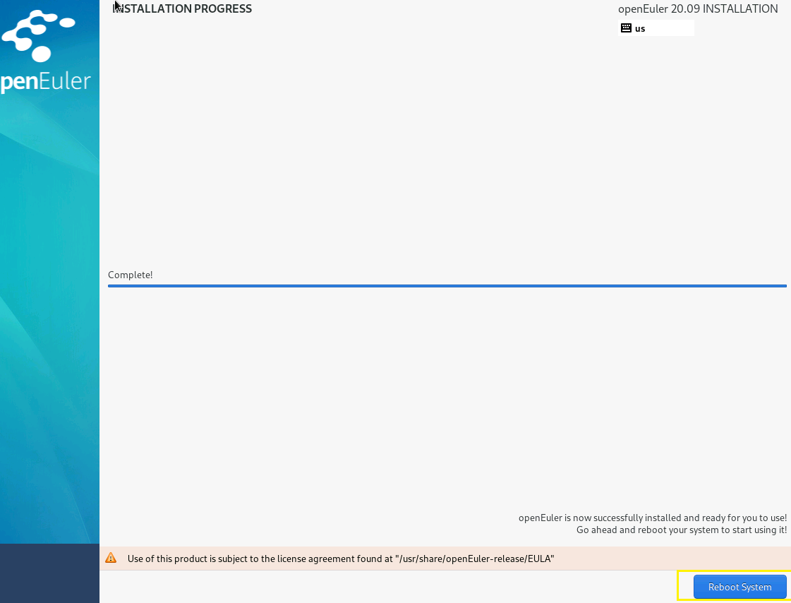

Note: in Virtual machines such as hyper-V, it’s necessary to turn off the VM, to be able to modify the boot sequence.

- Enjoy openEuler
